INSTALLATION OF TERRAFORM

IN LINUX:

1. Install unzip by typing command “sudo apt-get install unzip”

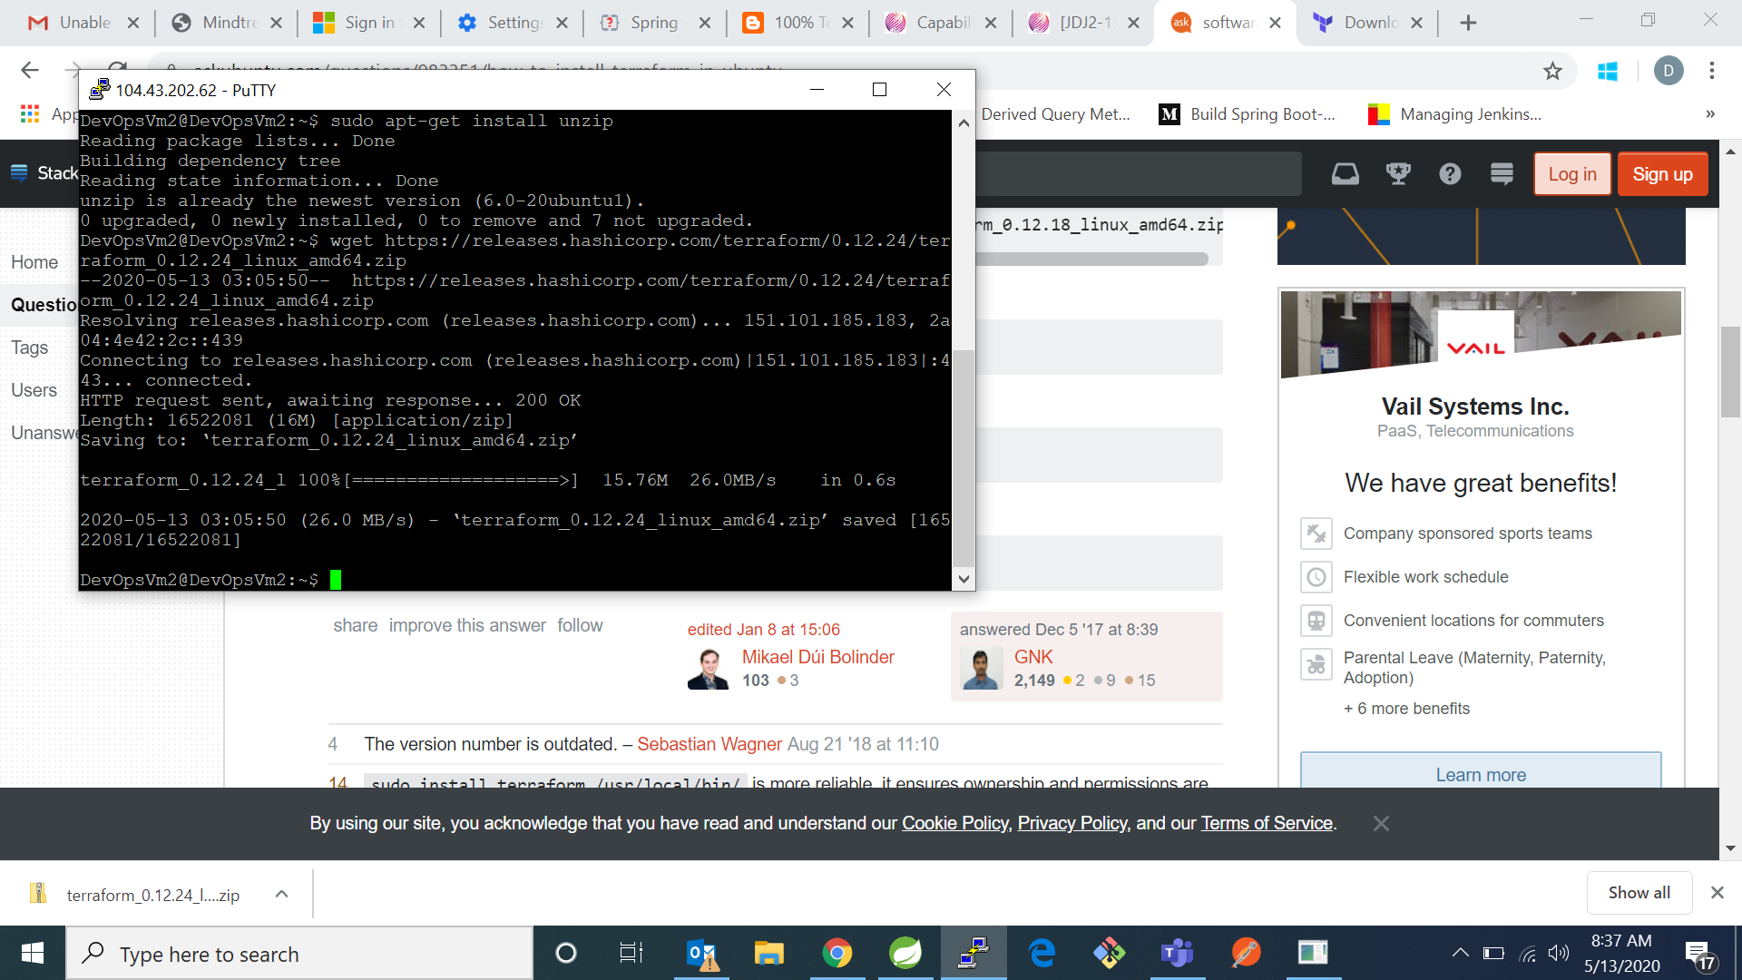

1. Now get the latest versiion of terraform by typing command:

“wget <https://releases.hashicorp.com/terraform/0.12.24/terraform_0.12.24_linux_amd64.zip>”



1. Now type command “unzip terrform_0.12.24_linuxamd64.zip” to unzip the zip fil

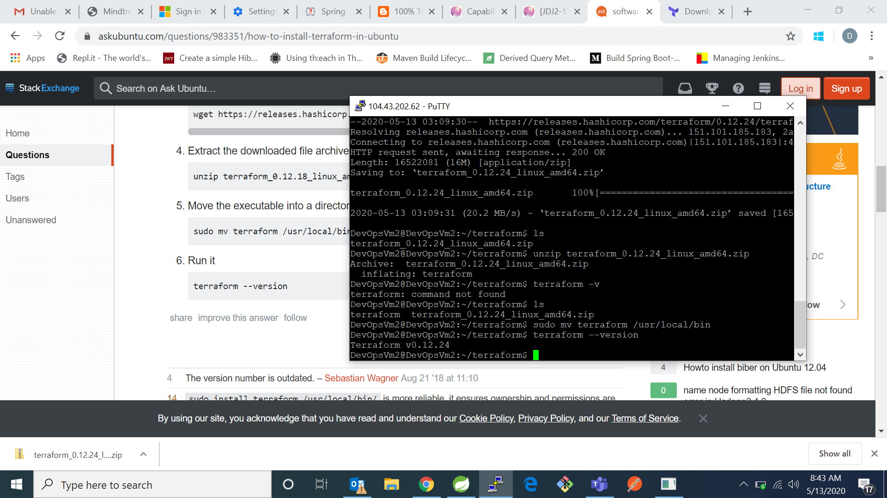

1. Now type command “sudo mv terrform /usr/loacl/bin”



1. Now check for terraform version bt typing command “terraform –version”



IN WINDOWS:

1. Go to download terraform page and click for Windows 64-biits

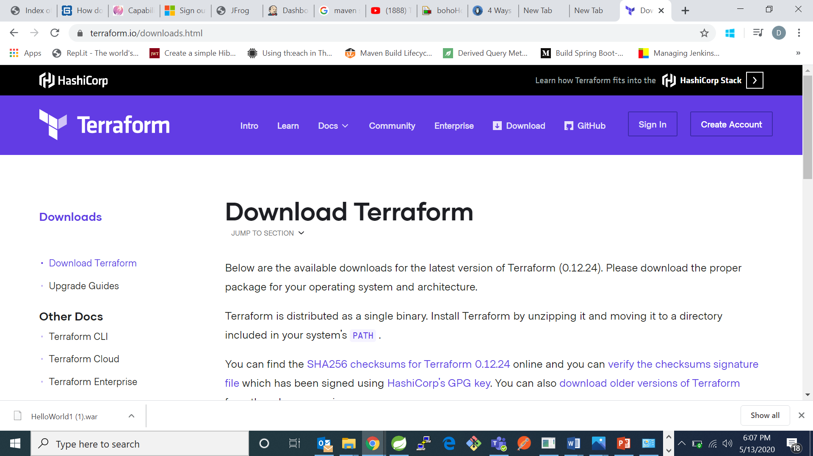

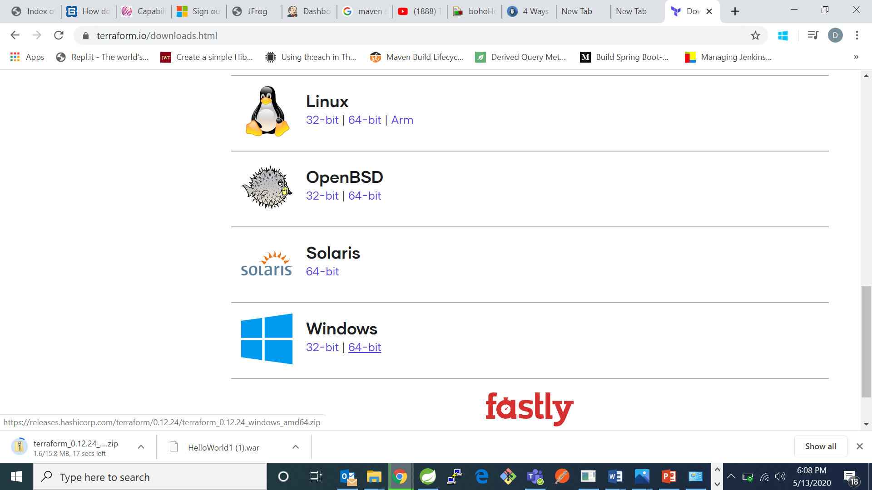

1. Now got downloads and extract in your C Drive

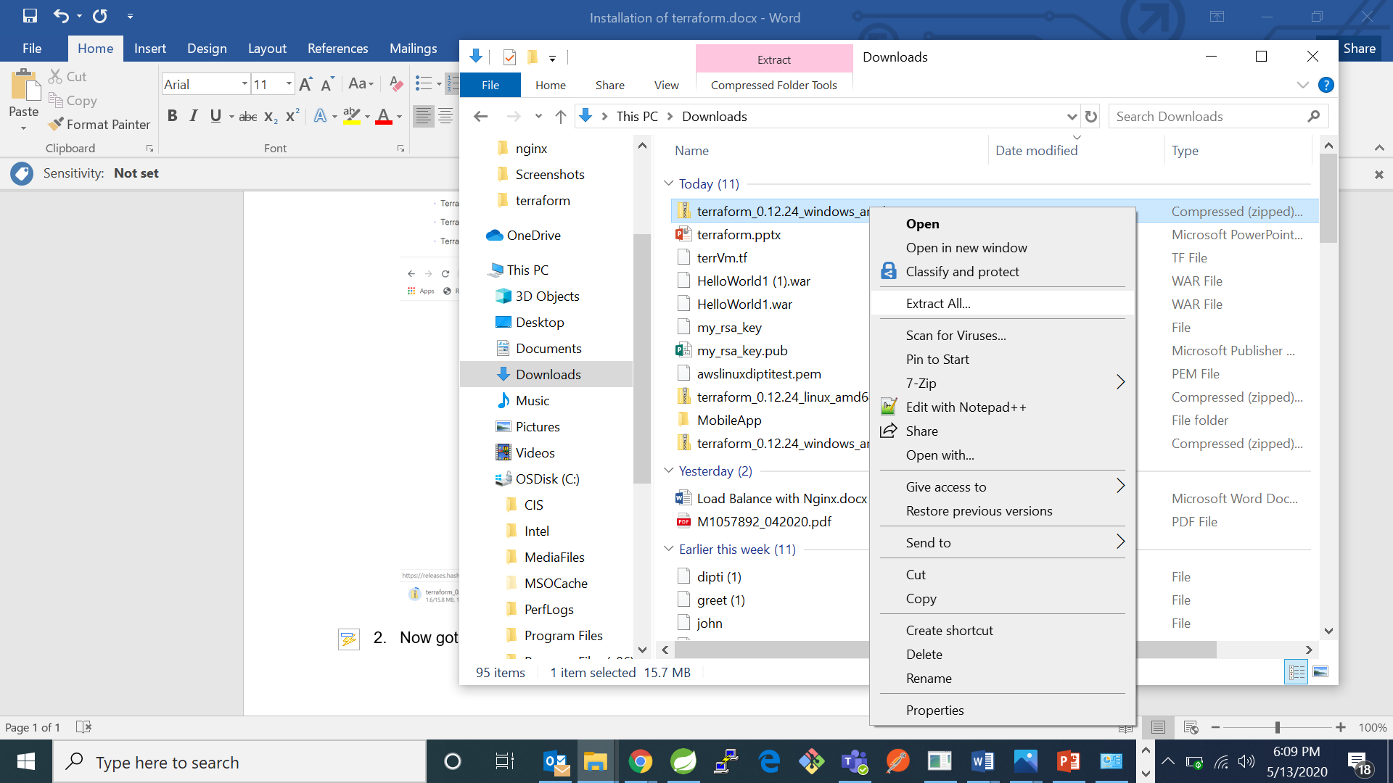

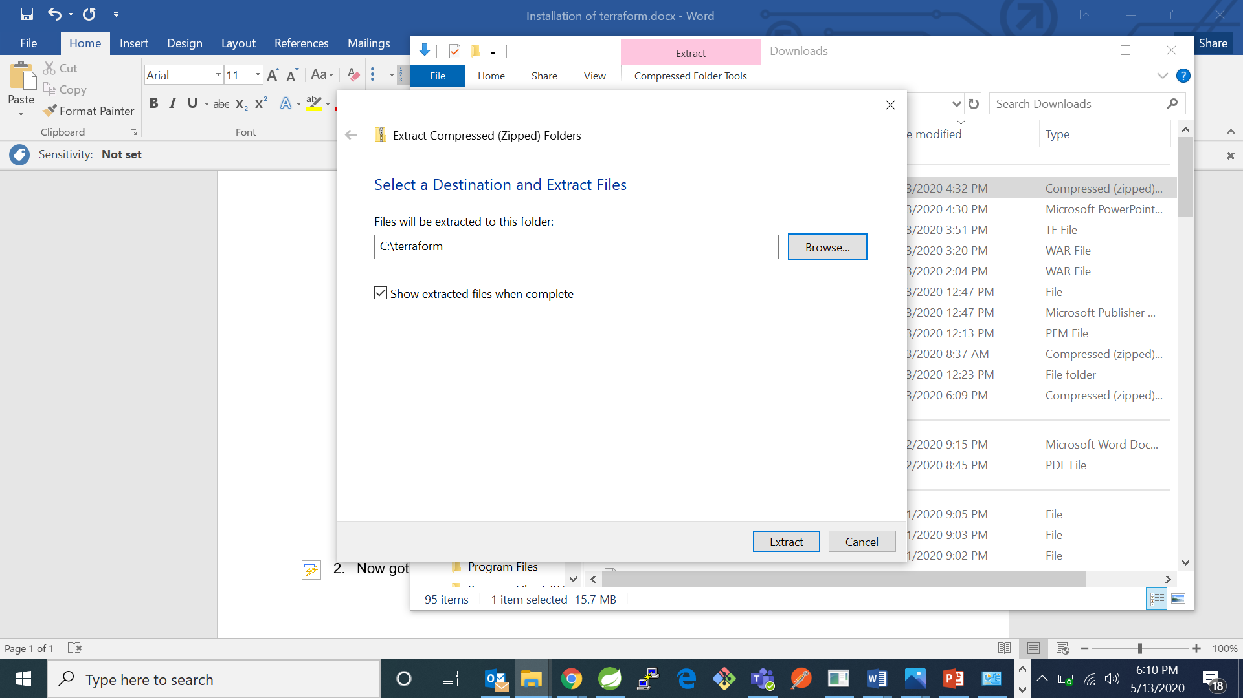

1. Now go to environment variables and add path:

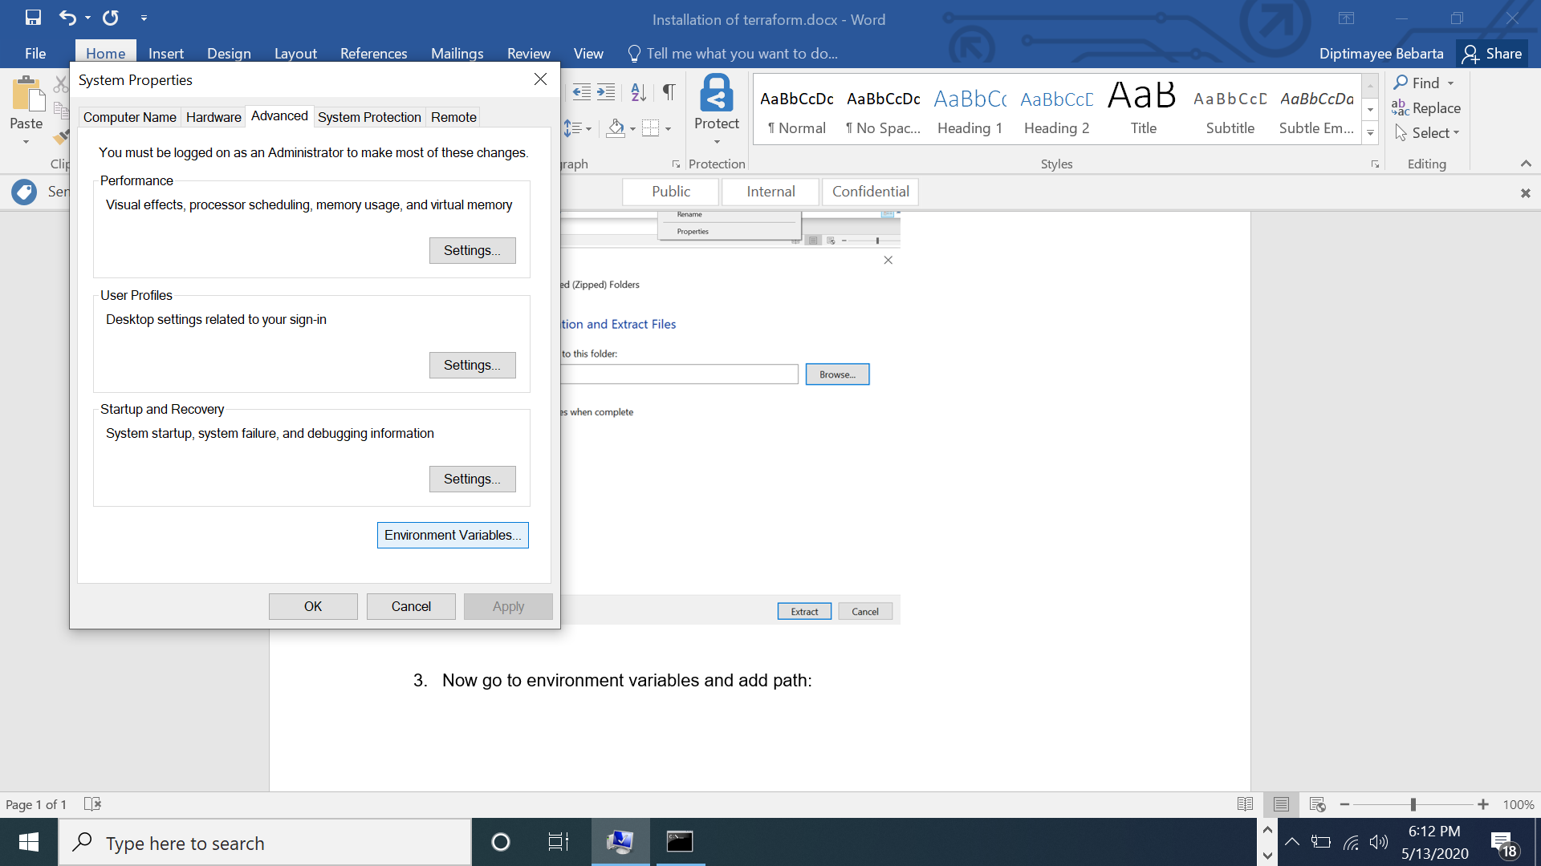

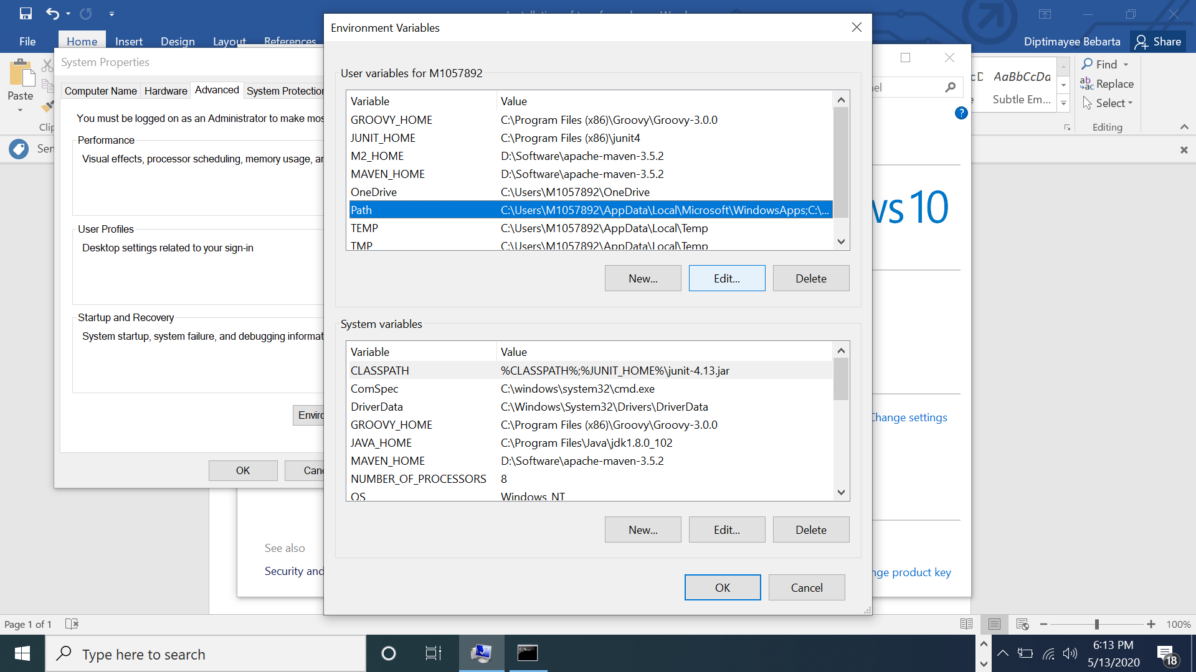

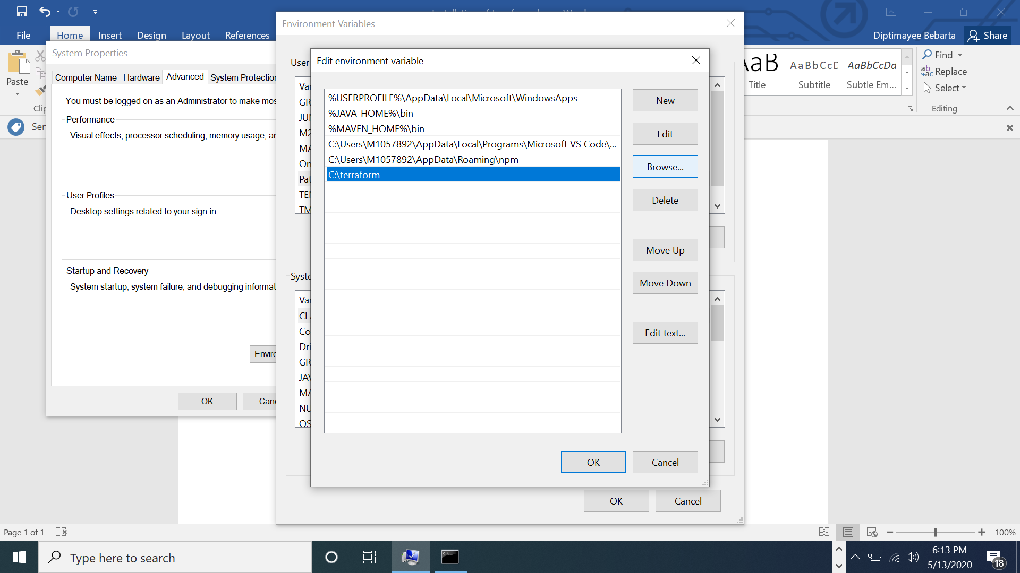

Then click ok.

1. Now go to your command line and type command “terraform”. It will give list of terraform commands.

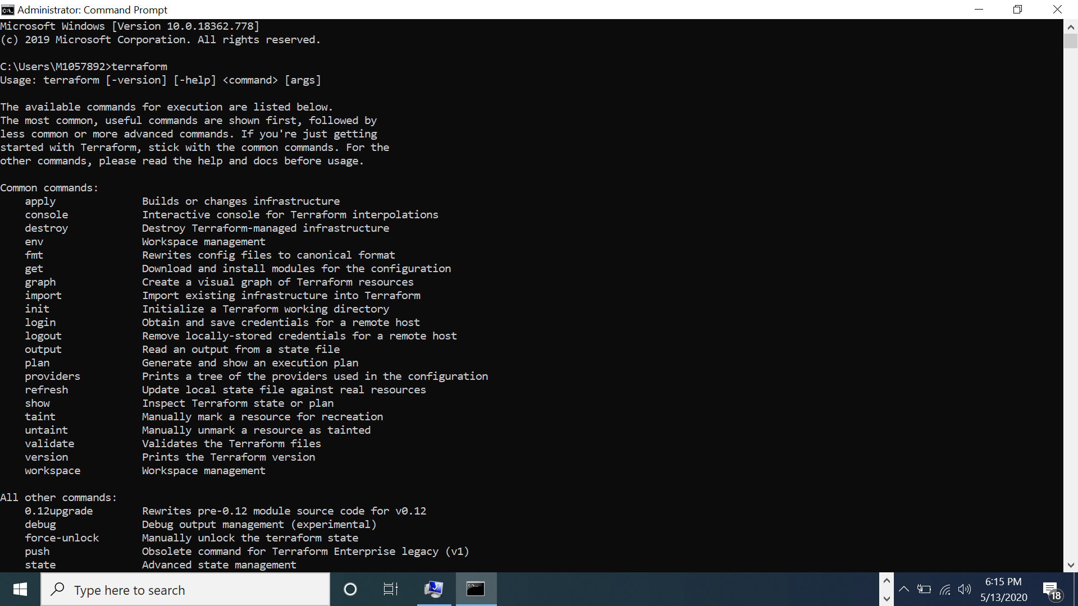

1. We can also check for terraform version: “terraform --version”

